Project Plan

Virtual Letter of Life (VLOL) Application

Version 1.5

Heather Barnes

Andrew Coleman

Panhavorn Hok

Michael Marcucci

Michael Shaw

Kimberly Van Allen

November 03, 2020

Revision History

|  |  |  |
| --- | --- | --- |
| **Date** | **Version** | **Description** |
| 09/06/2020 | 1.0 | Initial Project Plan |
| 09/08/2020 | 1.1 | This version includes feedback from Mentor Roy Gordon |
| 09/16/2020 | 1.2 | This version includes feedback from Professor |
| 09/26/2020 | 1.3 | This version includes sections from the prior semester |
| 10/11/2020 | 1.4 | This version includes the master test plan |
| 11/03/2020 | 1.5 | Revised for end of semester |

Table of Contents

I. Statement of Need 6

II. Purpose of Project Plan 8

III. Project Deliverables/Milestones 8

IV. Definitions Acronyms, and Abbreviations 9

V. Scope Management Plan 9

1. Scope Statement 9

2. Product Scope: Refer to VLOL SRS 10

3. Product Acceptance Criteria 10

4. Production Deliverables 10

5. Product Assumptions 11

6. Scope Constraints 12

7. Out of Scope 12

8. Scope Conclusion 12

VI. Schedule 14

VII. Requirements Management Plan 18

1. Pending Functional Requirements: Refer to SRS 18

VIII. Integration Management Plan 18

IX. Change Management Plan 19

X. Quality Management Plan 19

1. Test Tools and Resources 19

1.1 Testing Tools 19

1.2 Operating Systems and Browsers 19

1.3 Hardware 19

2. Testing 20

2.1 Testing Strategy 20

2.2 Items to be Tested 20

2.3 Items not to be Tested 20

3. Assumptions, Constraints, and Risks 21

3.1 Assumptions 21

3.2 Constraints 21

3.3 Testing Risks 21

4. Entry and Exit Criteria 22

4.1 Entry Criteria 22

4.2 Exit Criteria 22

5. Pass/Fail Criteria 22

6. Suspension Criteria and Resumption Requirements 22

6.1 Suspension Criteria 22

6.2 Resumption Requirements 22

7. Summary Test Schedule 23

8. Defect Severity 23

9. Test Deliverables 24

XI. Resource Management Plan 25

1. Team Roles and Responsibilities 25

XII. Risk Management Plan 27

XIII. Communication Management Plan 29

XIV. Project Plan Approval Signatures 30

References 31

Appendix A 32

Table of Tables

Table 1: Project Deliverables 8

Table 2: Acronyms, and Abbreviations 9

Table 3: Project Breakdown 13

Table 4: Testing Risk Matrix 21

Table 5: Test Schedule 23

Table 6:Defect Severity 23

Table 7: Project Team Organization 25

Table 8: Outside Resources 25

[Table 9: Risk Probability Matrix 27](https://umgccapstone.sharepoint.com/sites/SWEN670Fall2020-DevTeam-VLOL/Shared%20Documents/Dev%20Team%20-%20VLOL/Milestone%202%20Resubmit/VLOL%20Project%20Plan%20V1.3.docx#_Toc53302014)

Table 10:Risk Table 27

Table 11:Communications Plan 29

Table of Figures

Figure 1: Project Plan page 1 15

Figure 2: Project Plan page 2 15

Figure 3: Project Plan page 3 16

Figure 4: Project Plan page 4 16

Figure 5: Project Plan page 5 17

Figure 6: RACI Matrix 26

# Statement of Need

The “Letter of Life” is a document used by emergency services in Salisbury and Montgomery County Maryland. Patients enter their medical information to include items such as chronic conditions, medications, allergies, primary care doctors, insurance, and emergency contact. Emergency Medical Services (EMS) encourage all residents to complete this form and place it either on their front door or refrigerator to enable EMS staff to provide better care to patients in the event of an emergency.

Figure 1 – Statement of need letter

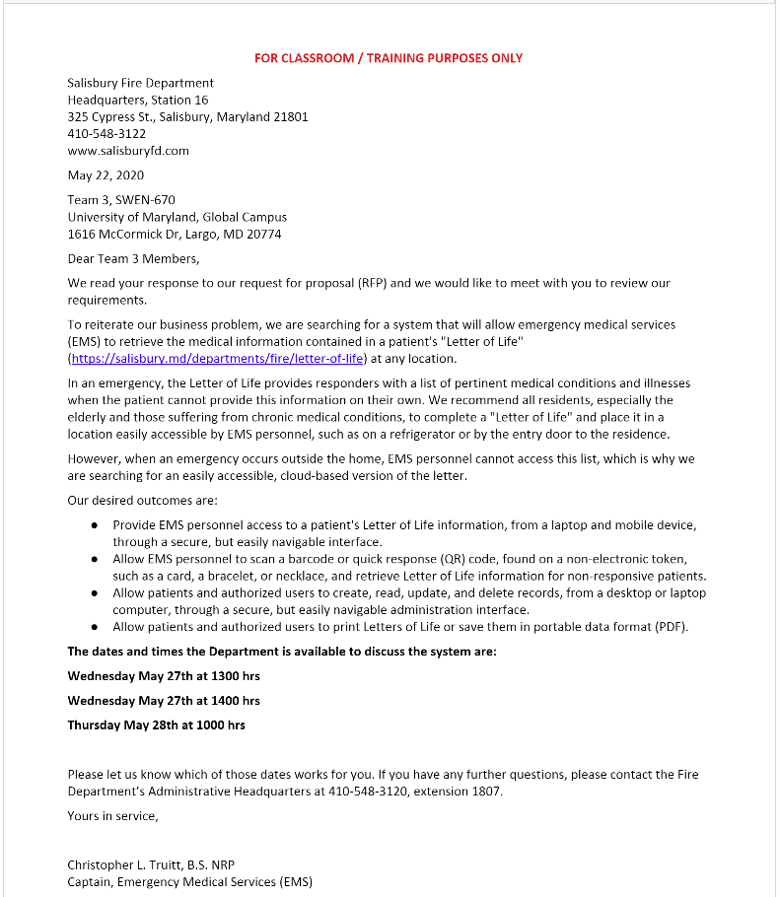

The scope of this project is to pick up where the previous team left off to continue to develop a website in which the “Letter of Life” can be filled out and viewed online. The website will enable patients to print out Quick Response (QR) codes that can be in an area of the user’s choosing. In Addition, there is a strong need that VLOL should be able integrate with other application where VLOL and potentially consume data and supply the data to other applications. EMS will be able to scan these QR codes to quickly obtain the virtual “Letter or Life”. Additionally, authorized users will not only be able to view a patient’s “Letter of Life” but make any necessary updates as needed. All documentation and code produced will be open source.

# Purpose of Project Plan

The intended audience for this document is stakeholders and the development team. This document provides a plan for how the development team will accomplish project goals and assess project risks. This is a living document that will be updated as needed to ensure that the goals of the project are being met and stakeholders are kept informed.

# Project Deliverables/Milestones

The below table shows the deliverables that will be submitted for each milestone. Deliverables may be revised based on client and stakeholder feedback and submitted again to the next milestone.

|  |  |
| --- | --- |
| Milestone | Deliverables |
| Milestone 1: September 2, 2020 | Software Reference Specification  Project plan  Team Roles and Presentation |
| Milestone 2: September 30, 2020 | Technical Design Document  Software Test Plan |
| Milestone 3: October 21, 2020 | Runbook  Programmer Guide |
| Milestone 4: November 11, 2020 | User Guide  Test Report  Final Presentation  Final Revision of Project Plan  Final Revision of Runbook  Final Revision of Test Plan  Final Revision Programmer Guide |

Table 1: Project Deliverables

# Definitions Acronyms, and Abbreviations

The below table has a list of acronyms and abbreviations found in this document.

|  |  |
| --- | --- |
| Acronym or Abbreviation | Definition |
| CCB | Change Control Board |
| CRISP | Chesapeake Regional Information System for our Patients |
| ER | Emergency Responder |
| HIPPA | Health Insurance Portability and Accountability Act |
| HTML | Hypertext Markup Language |
| IT | Information Technology |
| LOL | Letter of Life |
| MIEMSS | Maryland Institute for Emergency Medical Services Systems |
| PMBOK | Project Management Body of Knowledge |
| PMI | Project Management Institute |
| QA | Quality Assurance |
| QR code | Quick Response code |
| SDLC | Software Development Lifecycle |
| SRS | Software Requirements Specification |
| UI/UX | User Interface/User Experience |
| UMGC | University of Maryland Global Campus |
| VLOL | Virtual Letter of Life |

Table 2: Acronyms, and Abbreviations

# Scope Management Plan

## Scope Statement

The goal of this project is to enhance the Virtual Letter of Life Project initial design by the Summer 2020 UMGC Team. Initial requirements include completion of the requirements from the summer team, see Team 3 – Project Plan V5. On top of this, we will also be triaging the previous requirements and seeing if they still make sense given the new requirements. Furthermore, the team will be looking at ways to improve and enhance the current application for usability and to further develop the initial requirements. This scope will also include the potential to integrate with some third-party systems. As not all the requirements for this integration are currently available some padding will be included in the later sprints to allow for the inclusion of these requirements.

## Product Scope: Refer to VLOL SRS

## Product Acceptance Criteria

The initial product acceptance criteria as documented by last semester’s team was approval by project sponsor, Captain Christopher L. Truitt of the Salsbury Fire Department. This product currently has several stakeholders and once the communication with the potential third-party integrations is established may gain a few more. Given that we are working with some primary stakeholders and the goal of this product release will be to satisfy the requirements that both the primary stakeholders and the team agree can be completed in the development timeline.

## Production Deliverables

* + Reduced time spent searching through accurate patient information
  + Enhance security to ensure the security of patients’ sensitive data storage and accessibility: allowing information to be viewable to the users with regard to their level of access based upon their level of position.
  + Accessibility to patients to easily update their medical information to ensure accurate information sharing between first responders and other authorized personnel
  + The system will monitor who is accessing patient information and provide data for audit.
  + Patients will be provided a barcode identifier at the time of registration, to be scanned by authorized users to view patient information. This will prevent the open display of patient information increasing security and patient privacy.
  + A way for users and providers to access, share and store personal health information.
  + Security to conform with HIPPA regarding personal health information.
  + Accessibility for providers to find patient information through a multitude of ways including portable barcodes for a patient to keep on them, or by searching the patient in the database.
  + The capability/requirements gathering to allow integration with the stakeholders’ third-party medical systems.
  + A test suite is capable of fulfilling the testing of the application to confirm the interfaces' work and can handle different types of data inputs.
  + Documentation related to the installation and setup of the application to a production environment.
  + A scalable product that can handle multiple users accessing the environment at any one time.

## Product Assumptions

The assumptions in this product are that this product will be used in a live production environment to store personal health information. As such administration of the users is handled appropriately and access is given to qualified registrants.

* 1. Technical Details:
     + The back-end will use Java 11 with a PostgreSQL based H2 database.
     + Framework: Spring Boot
     + Data: Spring Data, ORM is Hibernate
     + Coding environments are Linux and Windows
     + Client-side languages used will be JavaScript, HTML, and CSS.
     + The source control system will be Git
     + The deployment pipeline will use Microsoft Azure
     + Docker will be used for containerization of application

## Scope Constraints

The scope of this project includes an 11-week period during which the product team will be employed, all timelines will reflect this and some of the product goals will include information related to passing the product on to the next team.

## Out of Scope

* + The product will not be deployed by the development team to a production environment. Instead, the development team will be responsible to help the DevSecOps team to deploy the application automatically.
  + Although the product team will be communicating with several potential partners, and every effort will be made to include these integrations into the scope, integrations with any third-parties may only be documented for further development and not included in the current product scope.
  + Any ongoing maintenance that would be required for a production application

## Scope Conclusion

The deliverable for this product will include a working application that can be used to store personal health information. Going forward, the team's vision for the VLOL project centers around integrating it with Health Information Exchange databases, so that it can serve people throughout the United States while maintaining up-to-date records of their medical information. The product release will be considered a success if it can be tested by both the automated test suite and stakeholders. Another requirement for the product to be considered a success if the web application can produce a QR read a produced QR code and present the collected user health information

**Project Breakdown**

|  |  |
| --- | --- |
| **Feasibility** | * The project team meets to discuss the feasibility of the proposed project. * Project team requests & secure sponsorship, define project scope, define and assume a role within the team. * The project team meets to discuss all the unfinished requirements from last semester and filter out the one that team thinks is beneficial to the stakeholders the most. |
| **Initiation** | * The project team will meet with the project owner/client to review the needs and requirements for the Virtual Letter of Life software. * The project team will provide solutions and recommendations to make sure all the requirements will be met, and the project will be completed accordingly. * The project team will discuss and decides appropriate language and database choices. * The Project Manager will prepare the project plan detailing important steps project information and key milestones and submit for approval. |
| **Design** | * The project team will create a system and database design. * The project team will hold a project meeting to approve the design and communicate the roles and responsibilities of the upcoming development phase. |
| **Development** | * Begin designing the Virtual Letter of Life software; inclusive of the database, backend, and UI/UX development. * Perform Unit Testing. * Perform Selenium Testing * Perform Integrate Testing |
| **Testing** | * Product testing will be performed according to the test plan. * Resolve any issues that may arise during testing. * Re-test the software until the product runs error-free. |
| **Closeout** | * Document records for future project reference. * Demonstrate and deliver complete software. * Update and deliver the project plan and any supporting documents. |

Table 3: Project Breakdown

# Table 4: Project Breakdown Schedule

The VLOL Team will follow a standard Software development Lifecycle (SDLC) of plan, design, develop, and implement. Using an agile methodology, the team will divide the work into 5 sprints. At the end of the fifth sprint, the VLOL team will close out the project with the final deliverables and demonstration being turned over to the project stakeholders. Below is a copy of the VLOL team’s project schedule.

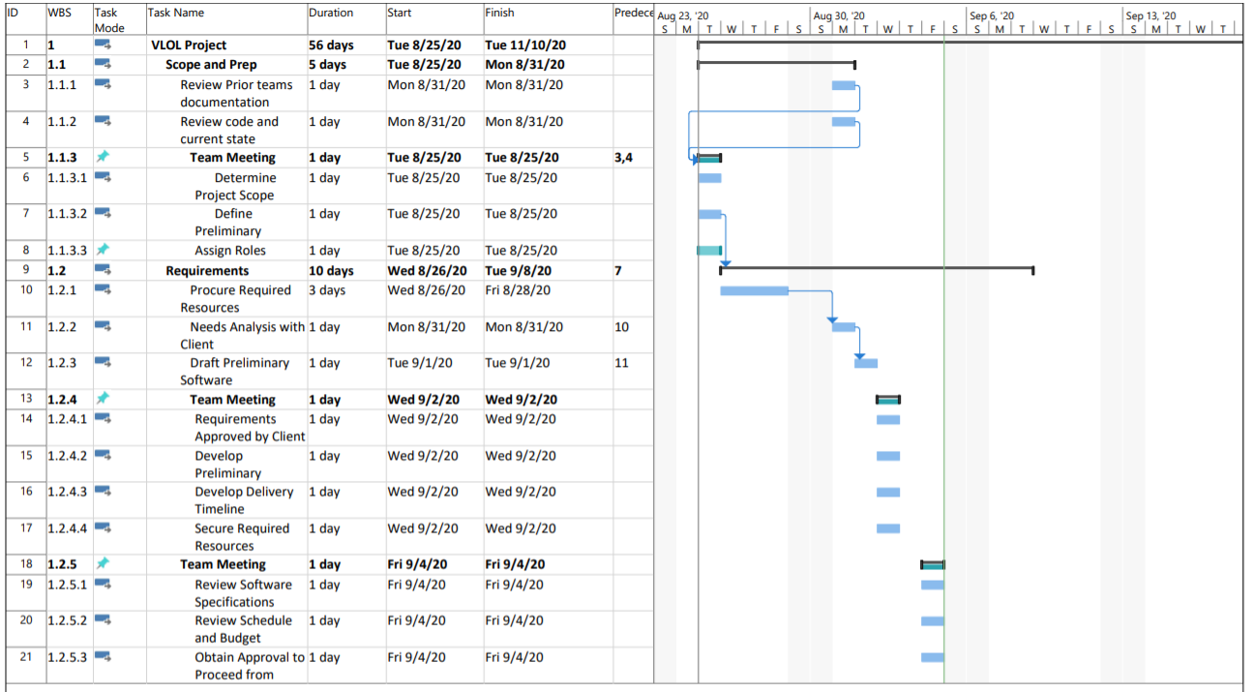

Figure 1: Project Plan page 1

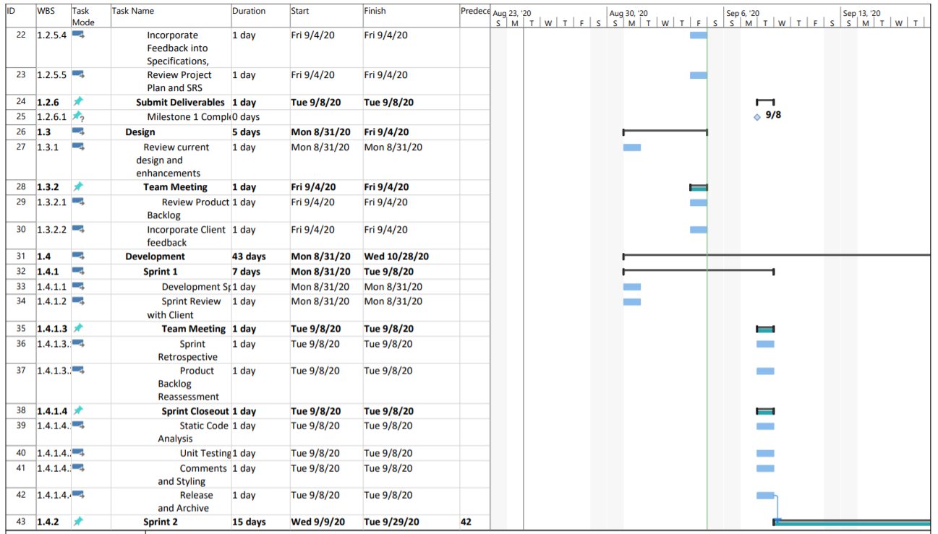

Figure 2: Project Plan page 2

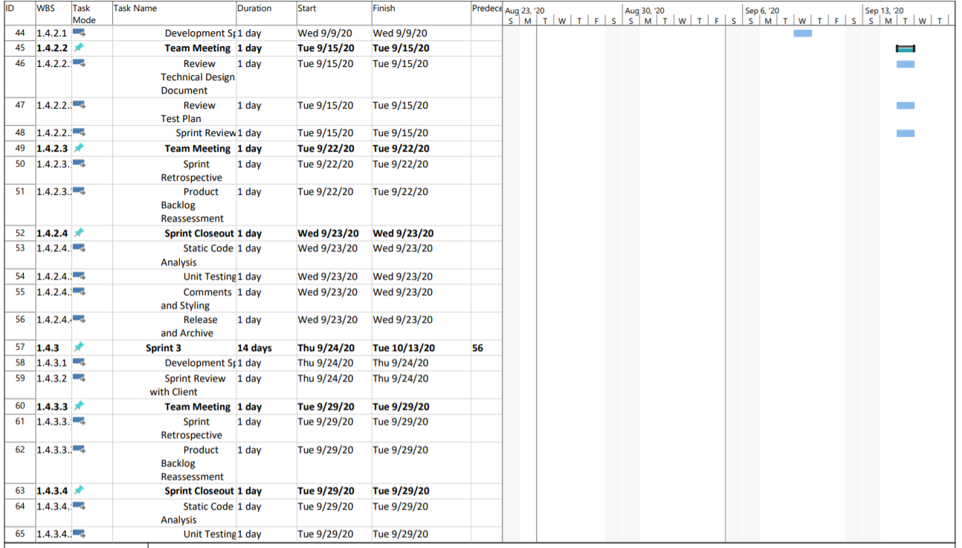

Figure 3: Project Plan page 3

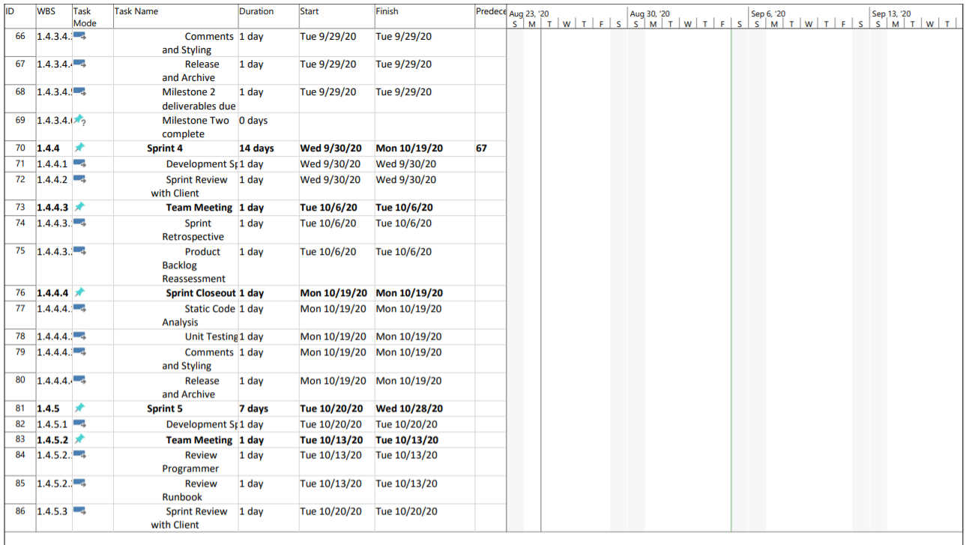

Figure 4: Project Plan page 4

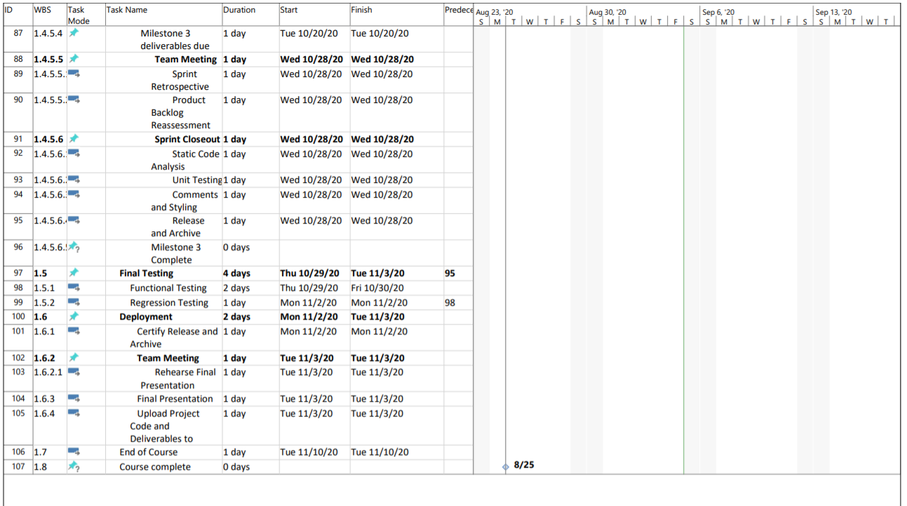

Figure 5: Project Plan page 5

# Requirements Management Plan

In tables included in the SRS, the pending functional requirements to be implemented by the project team are shown. Some requirements were inherited from the previous team in a partially-complete state, so the current status of each requirement is included. See the VLOL System Requirements Specification for details regarding requirements completed by the previous team, as well as inherited requirements that have been discarded by the current team.

## Pending Functional Requirements: Refer to SRS

# Integration Management Plan

For external integrations, the VLOL team has held initial talks with the client on their desire to integrate with vendors including CRISP. The client will initiate discussions first with a state agency called MIEMSS, who will set the standard of integration with any third-party vendors. Emails to other state agencies will be sent to increase the number of stakeholders for possibly more integrations in future classes. After this step is completed, the VLOL team can define a clear set of requirements and technical details for integration. Each requirement will be documented as well as technical specifications for data and software integration concerns using the available information during the project time period. Possible risks of integration will also be documented at that time.

For internal integrations, the VLOL team collaborates when creating and editing documents using Teams. For code integration, the VLOL team has a process of tracking and monitoring the progress of tasks through Trello. The team also uses Git for source control management. Each member of the team will also adhere to common team standards when making documentation or code contributions to the project.

# Change Management Plan

During the development lifecycle, the team is excepting requirements to come in at later stages of development. As such a plan has been put in place to determine what will be included in the product requirements. Although the team would like to include all of the requirements in the product the scope constraints may prevent their complete inclusion. The development team will receive and triage the requirements, this includes timelines for their completion, level of difficulty, and any risks associated with them. From there the requirements will be taken to the primary stakeholders, the project managers will then discuss these requirements with the stakeholders to prioritize them and if agreed included them in the scope of the project. Any other requirements will be retained and documented, to be slated for further development opportunities.

# Quality Management Plan

## 1. Test Tools and Resources

### **1.1 Testing Tools**

The following testing tools will be used:

* **Selenium 3.17.0**– an automated testing tool that will be used by developers and testers to test against the VLOL application. Selenium tests will be used to ensure that units of code work together.
* **Junit 4.13**– a unit testing framework for Java language. JUnit will be used by developers to ensure units of code work.
* **Trello** – this project management software tool will be used by the development team to post, update, track, and fix defects in the VLOL application.
* **MS-Word 2007 Build 13029.20344 –** aword processor that will be used by the development team to produce testing reports.

### **1.2 Operating Systems and Browsers**

* Windows 10
* Firefox 80.0.1
* Chrome 85.0.4183.102

### **1.3 Hardware**

* Laptop: Dell Inspiron
* Mobile Device: Samsung A51

## 2. Testing

### **2.1 Testing Strategy**

A continuous testing approach will be used. Unit, Integration, and System testing will be done as development work is completed. This approach will ensure defects are found early and the development team can maintain the tight schedule of the project.

### **2.2 Items to be Tested**

The list below identifies all the items that will be used as a target for testing:

* Unauthenticated User
  + Access to an informative Landing page to learn about the Letter of Life program.
  + Access to a Contact page for information solicitation about the Letter of Life program or contact the System Administrator about an issue.
  + Access to a secure Registration page to enroll in the Letter of Life program.
* Program Participant
  + Access to secure Letter of Life Login Page.
  + Create or delete the VLOL account.
  + View/Add/Edit/Delete Letter of Life information.
  + Print a barcode or quick response (QR) code with a link to Letter of Life
* Medical Services Provider
  + Access the Letter of Life system via a Login Page
  + Edit profile information via an online form to ensure profile information is up to date.
  + Search & View for patients on a laptop or mobile device via an online form to retrieve their medical history and provide correct medical care.
  + Search & View for a patient by scanning a barcode or quick response (QR) code, using a mobile device or authorized accessory.
  + Access to a secure Contact page to contact the System Administrator about an issue.
* System Administrator
  + Access the VLOL system via a Login Page.
  + Search for user accounts on a laptop or mobile device via an online form to add, view, edit, and delete user accounts, as necessary.
  + View/Add/Edit/Delete accounts for Medical Services Providers and Patient Advocates to limit non-patient access to patient information.
  + View a system error log to inform the development team of problems or issues with the application.
  + View a system activity log.

### **2.3 Items not to be Tested**

The following items are not in scope to be testing by the VLOL team.

* Network Security
* System deployment
* Load and Stress Testing

## 3. Assumptions, Constraints, and Risks

### **3.1 Assumptions**

* The client will be available for User Acceptance Testing.

### **3.2 Constraints**

* The short timeline and may require testing items to be prioritized based on importance.

### **3.3 Testing Risks**

The majority of the software risk that could impact the project was listed in the Project Plan Risk Management Plan section. Most of the risks were categorized as a low-level risk. The table below provides risks that will impede testing:

Table 5: Testing Risk Matrix

|  |  |  |  |
| --- | --- | --- | --- |
| **Item** | **Risk** | **Impact** | **Mitigation Plan** |
| 1 | Insufficient communication on testing in the team or with key stakeholders. | Low | Weekly meetings to discuss team status and impediments will be held. |
| 2 | Unexpected project scope expansions. | Medium | Working in short iterations the development team will provide demonstrations of new functionality and get stakeholder feedback. |
| 3 | Wrong testing time/resource estimations. | Low | The VLOL team will be continuously testing with a dedicated tester |
| 4 | Tight timeline development and testing activities | Medium | The VLOL team will be continuously testing with a dedicated tester |
| 5 | Continuous changing requirements. | Medium | Working in short iterations the development team will provide demonstrations of new functionality and get stakeholder feedback. |
| 6 | Failure to address requirements/testing priority conflicts. | Low | Weekly meetings to discuss team status and impediments will be held. |
| 7 | Insufficient communication on testing in the team or with key stakeholders. | Medium | Weekly meetings to discuss team status and impediments will be held. |
| 8 | Insufficient testing resources. | Low | A dedicated tester will be assigned to the project |
| 9 | Insufficient subject matter knowledge. | Low | Weekly meetings to discuss team status and impediments will be held. |

## 4. Entry and Exit Criteria

### **4.1 Entry Criteria**

The following criteria will be required before testing can begin:

* A test environment will be set up
* All hardware and software are installed and successfully functioning
* Tester has been trained
* Requirements have been clearly defined
* Test cases have been written, reviewed, and approved

### **4.2 Exit Criteria**

* Testing of all items in scope has been completed
* All test cases have been executed
* All severe defects have been fixed and retested
* All minor defects have been documented

## 5. Pass/Fail Criteria

The following criteria will be used to determine if the system has passed or failed

* All major functionality in the system shall be working as intended
* There shall be no critical or major bugs identified
* 90% of all test cases must pass

## 6. Suspension Criteria and Resumption Requirements

### **6.1 Suspension Criteria**

Testing activities will be suspended when one of the following occur:

* The testing environment is unavailable
* When a defect is found that prohibits further testing
* Significant requirement changes have been requested by the client

### **6.2 Resumption Requirements**

For testing activities to resume the cause of the suspension must be resolved.

## 7. Summary Test Schedule

|  |  |  |  |
| --- | --- | --- | --- |
| **Sprint** | **Task Name** | **Task Due Date** | **Comment** |
| 1 | Unit Testing | 09/07/20 | Development team to complete |
| 1 | Functional Testing | 09/08/20 | Tester to complete |
| 1 | Sprint Review | 09/09/20 | Development team and stakeholders |
| 2 | Unit Testing | 09/22/20 | Development team to complete |
| 2 | Functional Testing | 09/23/20 | Tester to complete |
| 2 | Sprint Review | 09/24/20 | Development team and stakeholders |
| 3 | Unit Testing | 09/28/20 | Development team to complete |
| 3 | Test Plan delivered | 09/29/20 | Development team to submit Test Plan |
| 3 | Functional Testing | 09/29/20 | Tester to complete |
| 3 | Sprint Review | 09/30/20 | Development team and stakeholders |
| 4 | Unit Testing | 10/18/20 | Development team to complete |
| 4 | Functional Testing | 10/19/20 | Tester to complete |
| 4 | Test Plan Updated and Interim Test Reports Delivered | 10/20/20 | Development team to submit |
| 4 | Sprint Review | 10/20/20 | Development team and stakeholders |
| 5 | Unit Testing | 10/28/20 | Development team to complete |
| Final Testing | Functional Testing | 10/30/20 | Tester to complete |
| Final Testing | Regression Testing | 11/02/20 | Tester to complete |
| Final Testing | Complete and Review Test Report | 11/03/20 | Tester to complete |

Table 6: Test Schedule

## 8. Defect Severity

Defects will be prioritized to be fixed based upon the severity outline in the table

|  |  |  |
| --- | --- | --- |
| **ID** | **Severity** | **Description** |
| S1 | Critical | The defect causes the system to be unusable. The defect has no workaround. |
| S2 | Major | The defect harms the system performance or processes. There is a workaround, but it is not easy. |
| S3 | Medium | The defect affects minor functionality and has an easy workaround. |
| S4 | Low | The defect does not affect the functionality and does not need a workaround. |

Table 7:Defect Severity

## 9. Test Deliverables

The acceptance criteria for these deliverables will be directly linked to the Product Deliverables in the Project Plan under section V.5. The test deliverables are as follow:

* **Test Plan** (this document)
* **Unit Test plan**
  + White Box Testing
    - Personal Health Data will be date and time stamped, inclusive to medication management, and continuity of care.
    - The system will monitor who is accessing patient information and provide data for audit
* **User Acceptance Test** (UAT) plan
  + Black Box Testing
    - Reduced time spent searching through accurate patient information
    - Enhance security to ensure the security of patients’ sensitive data storage and accessibility: allowing information to be viewable to the users concerning their level of access based upon their level of the position.
    - Accessibility to patients to easily update their medical information to ensure accurate information sharing between first responders and other authorized personnel
    - Accessibility to patients to easily update their medical information to ensure accurate information sharing between first responders and other authorized personnel
* **Test Reports**
  + Test Incident report
  + Test summary report

# Resource Management Plan

The project team’s organization is shown in the table below.

|  |  |  |  |
| --- | --- | --- | --- |
| Name | Role | Estimated Hours | Rate |
| Michael Shaw | Project manager | 110 | $48.95 hourly |
| Heather Barnes | Project manager | developer | 110 | $48.95 hourly |
| Panhavorn Hok | Developer | 110 | $37.50 hourly |
| Michael Marcucci | Developer | Tech Lead | 110 | $37.50 hourly |
| Andrew Coleman | Developer | documentation | 110 | $37.50 hourly |
| Kimberly Van Allen | Tester | 110 | $37.50 hourly |

Table 8: Project Team Organization

The outside resources that will contribute to the success are listed in the table below.

|  |  |
| --- | --- |
| Name | Role |
| Dr. Mir Assadullah | Advisor |
| Roy Gordon | Advisor |
| Robert Garcia | Client |
| Avital Graves | Client |

Table 9: Outside Resources

## Team Roles and Responsibilities

The RACI chart below displays the roles and responsibilities of each of the project team members.

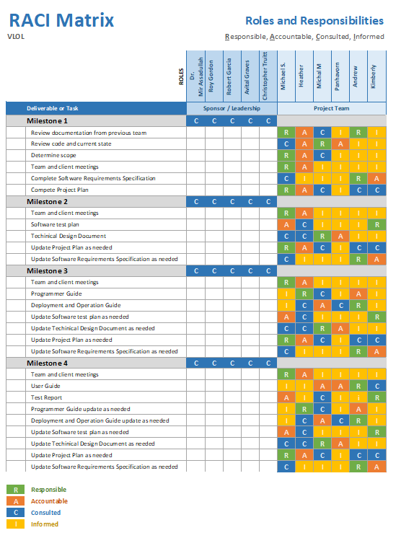

Figure 6: RACI Matrix

# Risk Management Plan

To ensure product development success the development team has identified a list of risks that can hinder the product development lifecycle and the production schedule. The mitigation plan includes steps to take to avoid the risk. The contingency plan is the steps that can be taken in case the risk was to develop.

Markovic, I. (2019). Likelihood: the probability of a risk. Retrieved from https://tms-outsource.com/blog/posts/risk-assessment-matrix/  
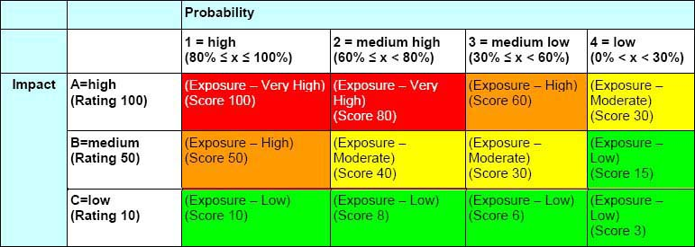

Table 10: Risk Probability Matrix

|  |  |  |  |  |  |
| --- | --- | --- | --- | --- | --- |
| Possible Event Risk | Probability | Impact | Score | Mitigation Plan | Contingency Plan |
| Unable to Maintain Product Schedule | Low | B | 15 | Prioritize tasks such that key deliverables are given priority over unimportant tasks.  Frequently review the tasks and project status. | Identify the problem source.  Adjust the scope and priority of tasks with the stakeholders and present a new timeline. |
| Product Scope Creep | High | B | 50 | Prioritize the tasks and the key deliverables such that the product release can be considered a success.  Frequently review the tasks and project status. | Cut the scope down and create the requirements for the next development team. |
| Broad/many requirements | Medium- High | A | 80 | Communicate with the stakeholders to ensure the breakdown of the requirements. | Work within the key deliverables to breakdown and triage the tasks.  Document the requirements for the next development team. |
| Loss of development resources | Low | A | 30 | Work with the team to identify and fix the issue.  Ensure roles are cross-trained and can fill in gaps. | Work with the resources available and alter the development plan to meet the key deliverables. |
| Stakeholder Acceptance | Low | A | 30 | Ensure all requirements that have been agreed upon are met.  Ensure testing of all requirements to ensure they will work in production.  Meet and demonstrate the product to the stakeholders periodically. | Document the missing acceptance criteria for the next product lifecycle. |
| HIPPA Compliance | Low | A | 30 | Ensure security takes priority when it comes to deliverables and development tasks.  Ensure testing includes security compliance testing. | Prioritize security for the next product development schedule.  Document the requirements for fixes for the product transition. |

Table 11:Risk Table

# Communication Management Plan

|  |  |  |  |  |
| --- | --- | --- | --- | --- |
| Communication Type | Objective of Communication | Method | Frequency | Audience |
| Team Meetings | Planning  Testing  Review status | Microsoft Teams VLOL Channel | Weekly Tuesdays at 6:00 pm | Internal Project Team |
| Informal Communications | Various issues, questions, and concerns | Email  Microsoft Teams | As needed | Stakeholders, Mentor |
| Milestone Reviews | Review Documentation and get feedback | Microsoft Teams VLOL Channel  Email | End of each Milestone  Tuesday  6:00pm | Internal Project Team  Roy Gordon |
| Stakeholder Meetings | Review any updates  Concerns | Email  Microsoft Teams | Based on Stakeholder availability | Internal Project Team  Stakeholders |
| DevOp Meetings | Various issues, questions, and concerns  Deployment Meetings | Microsoft Teams DevOps Channel | As needed | Internal Project Team  DevOps |

Table 12:Communications Plan

Template - Project Plan Approval v1.0.1 03/01/06

Template: Project Plan Approval Signatures

Project Name:

Project Manager

_______________________________________ __________________

(Signature) (Date)

Name

Position

Organization

Project Sponsor

_______________________________________ __________________

(Signature) (Date)

Name

Position

Organization

Organization

Project Customer

_______________________________________ __________________

(Signature) (Date)

Name

Position

Organization

Project Customer

_______________________________________ __________________

(Signature) (Date)

Name

Position

Organization

Template - Project Plan Approval v1.0.1 03/01/06

Template: Project Plan Approval Signatures

Project Name:

Project Manager

_______________________________________ __________________

(Signature) (Date)

Name

Position

Organization

Project Sponsor

_______________________________________ __________________

(Signature) (Date)

Name

Position

Organization

Organization

Project Customer

_______________________________________ __________________

(Signature) (Date)

Name

Position

Organization

Project Customer

_______________________________________ __________________

(Signature) (Date)

Name

Position

Organization

# Project Plan Approval Signatures

Virtual Letter of Life

Project Manager

______________________________________ __________________

(Signature) (Date)

Name

Position

Organization

______________________________________ __________________

(Signature) (Date)

Name

Position

Organization

Michael Shaw__________________________ 11/03/2020______________

**(**Signature) (Date)

Michael Shaw

Project Manager

UMGC

Project Advisor

______________________________________ __________________

(Signature) (Date)

Name

Position

Organization

______________________________________ __________________

(Signature) (Date)

Name

Position

Organization

__________________________________________ ________________________

**(**Signature) (Date)

Dr. Mir Assadullah

Advisor

UMGC

Project Customer

______________________________________ __________________

(Signature) (Date)

Name

Position

Organization

______________________________________ __________________

(Signature) (Date)

Name

Position

Organization

__________________________________________ ________________________

**(**Signature) (Date)

Robert Garcia

Project Customer

Salisbury County EMS

Project Customer

______________________________________ __________________

(Signature) (Date)

Name

Position

Organization

______________________________________ __________________

(Signature) (Date)

Name

Position

Organization

__________________________________________ ________________________

**(**Signature) (Date)

Avital Graves

Project Customer

Montgomery County EMS

# References

A guide to the project management body of knowledge (PMBOK). (2017). Newtown Square, PA, EE. UU. Project Management Institute.

Robert Half. (2019, December 14). 6 basic SDLC methodologies: Which one is best [Web log post]? Retrieved September 06, 2020 from <https://www.roberthalf.com.au/blog/employers/6-basic-sdlc-methodologies-which-one-best>

Markovic, I. (2019). How to use the risk assessment matrix to organize your project better. Retrieved September 07, 2020 from https://tms-outsource.com/blog/posts/risk-assessment-matrix/

Piscapo, M. (2018). Requirements Management Plan. Retrieved August 30, 2020, from http://www.projectmanagementdocs.com/project-planning-templates/requirements-management-plan.html#axzz5J6f4HgMC

# Appendix A

Statement of need (Combined with Summer Semester).............................................................4-6

Definitions, Acronyms and Abbreviations(Combined with Summer)...........................................8

Scope Management Plan (Combined with Summer)…............................................................8-12